INVITATION TO BID

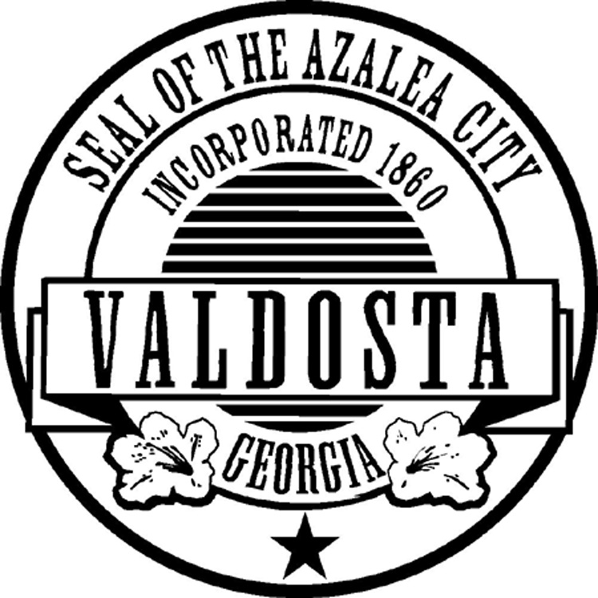

PURCHASING DEPARTMENT

P. O. BOX 1125

216 E. CENTRAL AVENUE

SECOND FLOOR

VALDOSTA, GEORGIA 31601

**BID # 17-24-25**

**FOR: (1) 2024-25 Asphalt Trailer**

**BID OPENING DATE**: **TUESDAY, DECEMBER 3RD, 2024**

**TIME: 10:20 AM EST**

**PURCHASING DEPT**

(229) 259-3525 • Fax (229) 259-5460

**NOTICE TO DEALERS/VENDORS**

1. Any prices bid by dealer/vendor on any items offered to the City of Valdosta shall be the price effective at the date of delivery.

2. No delivery date of “ASAP” (As Soon As Possible) shall be considered acceptable on items that have a maximum delivery date listed in the specifications.

3. The City of Valdosta reserves the right to accept alternate bids on any or all items where maximum delivery date, as listed in the specifications is not met by dealer/vendor.

4. Signature below of authorized agent for dealer/vendor shall constitute recognition and acceptance of all conditions of the sale as listed above.

5. All shipping is to be FOB Valdosta, GA 31601 and included in total price unless otherwise stated in the bid document.

6. Please be aware that private and public mail carriers are not always reliable on next day delivery in our area. Please assure your response is sent in plenty of time to reach us. As you know, late responses are not acceptable. If you utilize the US Postal Service and mail your response to the physical address, the chances are high it will be diverted to our post office box so allow extra time for delivery. Private carries will deliver to the physical address but include “Purchasing, 2nd Floor” in your delivery address and be aware that although you pay overnight fees, overnight delivery is not always successful although you are told the delivery time will be met.

____________________________________

Dealer/Vendor

Authorized Agent

**GENERAL SPECIFICATIONS**

It is the intent of these specifications to furnish the City of Valdosta with the following requisitioned equipment, according to the attached. It is clearly understood that the following are minimum specifications and are made in order to show the exact quality through specifications of the equipment proposed.

The City of Valdosta reserves the right to accept any or all bids or to choose the bid considered to be in their best interest.

The final decision of purchase will be made upon the award of the City of Valdosta Mayor and Council if the item or items total are greater than $25,000.

**Cooperative Procurement**

By signing this bid package, Vendor agrees it will permit piggyback purchases to this bid/contract for other government entities where governmental discounts apply such as city, county, local authorities, agencies, non-profits, boards of education, or other governmental agencies not listed offering the same prices, terms, and conditions offered to the City of Valdosta. Piggybacking shall only be available where competition was used to secure the contract and only for a period of 12-months following award date, or during renewals or extension periods of the contract. Also, the piggybacking will only be for the item(s) in the original bid/quote as they are specified with the exception of very minor changes. Changes such as engine size, pump size, different body style, etc. will not be allowed. This provision shall not apply to any contract where otherwise prohibited or mandated by state law.

**NO BID WILL BE CONSIDERED IF RECEIVED AFTER THE DATE AND TIME SPECIFIED.**

**Be sure to put the Bid Number on the outside of your return envelope.**

**INSTRUCTIONS TO BIDDERS**

1. Proposals must be made upon the form of the proposal attached hereto. They must be enclosed in a sealed plain envelope, with the bid number written on the outside and endorsed with the title of the proposal, and must be filed with the Purchasing Agent of the City of Valdosta, located at 216 E. Central Ave 2nd floor. In the event you choose to mail your proposal, it should be mailed to Teffany Edwards, P.A., P.O. Box 1125, Valdosta, Ga. 31603.

2. No bidder will be allowed to withdraw his proposal for any reason whatsoever after the bids have been opened.

3. The specifications represent the minimum general size, weight, capacity and performance characteristics desired in the equipment to be purchased. These requirements are not intended to prevent obtaining fair prices or to eliminate competition, but to insure, if possible, that all bids submitted shall not be subject to correction or alteration after the bid has been filed, opened, and publicly read. In view of an unusual wide disparity in details of design and manufacture, complete descriptive literature and manufacturer’s specifications must be submitted on each type of equipment offered. The City of Valdosta reserves the right to evaluate any or all bids, particularly where there is a range in specifications. Special consideration will be given to the ready availability of repair parts and service.

4. Federal or State taxes are not applicable to Georgia Municipalities under the United States Code Title 26 and Georgia Exemption Certificate Number 3-465-686-300-1.

5. It is expressly understood by the bidder that written notice of the award or purchase order by the City of Valdosta will constitute an agreement and consummate the transaction and will serve together with the proposal, the advertisement, these instructions and the detailed specifications, as the entire form of contract between the parties.

6. The bidder agrees that the City of Valdosta reserves the right to reject any or all proposals, or to accept the part of the bid considered to be in the best interest of the City.

7. Specifications referred to minimum, therefore unless otherwise indicated by the bidder, the City will assume proposals meet or exceed all specifications.

8. The names of a certain brand, make or definite specifications are to demote quality standard of the article desired, but do not restrict bidders to be specific brand, make or manufacturer named; it is to set forth and convey to prospective bidders the general style, type, character and quality of the article desired.

9. The award of the contract will be made to the lowest responsible bidder taking into consideration quality performance and the time specified in the proposals for the performance of the contract. The City of Valdosta reserves the right to reject all bids as appears in its own best interest and to waive technicalities. In cases of a tie, the bid in the best interest of the City will be awarded.

NON-COLLUSION AFFIDAVIT

The following affidavit is to accompany the bid:

STATE OF _________________

COUNTY OF _______________

_________________________________________________________

Owner, Partner or Officer of Firm

_________________________________________________________

Company Name, Address, City and State

Being of lawful age, being first duly sworn, on oath says that he/she is the agent authorized by the bidder to submit the attached bid. Affiant further states as bidder, that they have not been a party to any collusion among bidders in restraint of competition by agreement to bid at a fixed price or to refrain from bidding. Affiant also states as bidder, that they have not been a party to any collusion with any officer of the City of Valdosta or any of their employees as to quantity, quality or price in the prospective contract; and that discussions have not taken place between bidders and any office of the City of Valdosta or any of their employees concerning exchange of money or other things of value for special consideration in submitting a sealed bid for:

­­­­­­­­­­____________________________________

Firm Name

____________________________________

Signature

____________________________________

Title

Subscribed and sworn to before me this ______ day of _____________________, 20____.

____________________________________

Notary Public

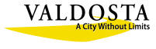

**GEORGIA SECURITY AND IMMIGRATION COMPLIANCE ACT AFFIDAVIT**

|  |  |
| --- | --- |
| Contract No. and Name: |  |
|  |  |
| Contractor’s Name: |  |

**City of Valdosta Georgia**

**Contractor Affidavit**

By executing this affidavit, the undersigned Contractor verifies its compliance with O.C.G.A. §13-10-91, stating affirmatively that the individual, firm, or corporation which is contracting with the City of Valdosta, Georgia has registered with and is participating in a federal work authorization program*, in accordance with the applicability provisions and deadlines established in O.C.G.A. 13-10-91.

The undersigned further agrees that, should it employ or contract with any subcontractor(s) in connection with the physical performance of services pursuant to this contract with the City of Valdosta, Georgia, the Contractor will secure from subcontractor(s) similar verification of compliance with O.C.G.A. § 13-10-91 on the Subcontractor Affidavit provided in Rule 300-10-01-.08 or a substantially similar form. Contractor further agrees to maintain records of such compliance and provide a copy of each such verification to the City of Valdosta Georgia at the time the subcontractor(s) is retained to perform such service.

_______________________________ __________________

EEV / E-Verify TM User Identification Number Date of Authorization

_______________________________ __________________

BY: Authorized Officer or Agent Date

(Contractor Name)

_______________________________

Title of Authorized Officer or Agent of Contractor

_______________________________

Printed Name of Authorized Officer or Agent

SUBSCRIBED AND SWORN

BEFORE ME ON THIS THE

____DAY OF _______________, 202__

_______________________________ [NOTARY SEAL]

Notary Public

My Commission Expires:______________

*any of the electronic verification of work authorization programs operated by the United States Department of Homeland Security or any equivalent federal work authorization program operated by the United Sates Department of Homeland Security to verify information of newly hired employees, pursuant to the Immigration Reform and Contract Act of 1986 (IRCA), P. L. 99-603

**SPECIFICATIONS**

It is the intent of these specifications to furnish City of Valdosta with **(1) one, 2024 or Newer, Brand Asphalt Trailer.** These are minimum specifications, and all deviations should be marked. Please return your marked deviations along with your proposal to this office. The City reserves the right to purchase at same price until June 30, 2025 if available.

**4 ton Hot Box Asphalt Trailer**

4-Ton Asphalt Hot Box

16’ Tandem Axle Trailer

Dual burner Recycler Package

Triple Wall Construction and Fully Insulated

Front and Rear Hopper Extensions

12-Volt Batteries

Battery Charger Package

24 Hour Timer

Automatic Temperature Control

Diesel Burner VIP Technology - Voltage Indicator and Protector Controller Automatically Prevents Burner(s) from Operating Below Burner Manufacturer's Required Voltage

One-Piece, Seamless Ceramic Combustion Chamber

Tandem Axle Trailer Frame - 2" x 6" x 1/4" Tubular Steel Construction

Independently Certified 92% Fuel Efficiency

Diamond Tread Plate Hopper Access Platform

Electric Brakes w/ Safety Breakaway

Conspicuity Tape

Dump Box (12-Volt Electric Over Hydraulic)

LED Lighting Upgrade - Two Red Stop/Tail/Turn Lights and One Amber Strobe each Side

LED night work lights

Strobe Warning Lights

ST235/80R 16" Tires - Load Range E

Release agent basket

3 position tool holder

5 position tool holder

Platform step

Black paint

15-gallon water tank

Spare tire and wheel with holder

20- pound fire extinguisher secured to trailer and covered

Hoist with 12-volt Winch Compactor basket

Sakai PC800 Plate tamp

**NO ARROW BOARD**

**PROPOSAL**

We/I have examined the specifications and agree to furnish the City of Valdosta with the equipment/services accordingly. Any deviations from the specifications will be marked exception on the bid sheet. We/I propose to furnish the City of Valdosta with said equipment/ service for:

Dollars Cents

$ Each

Date:

Company Name:

Address:

Phone Number: Cell:

Fax:

Signature: Title:

Printed Name:

Email:

Delivery: Days After Receive Order

Is your company currently on any State or Federal Debarment list? Yes____ No ____

Will you accept a credit card for payment? Yes ____ No ____

E-Verify Number: Include a copy in package

Include a W-9 in package.