INVITATION TO BID

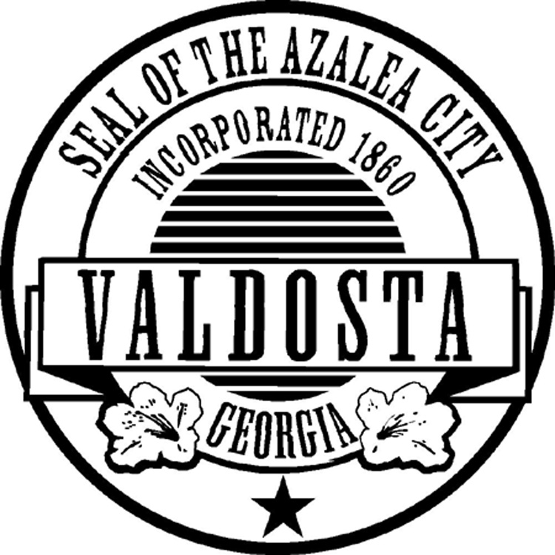

PURCHASING DEPARTMENT

P. O. BOX 1125

216 E. CENTRAL AVENUE

SECOND FLOOR

VALDOSTA, GEORGIA 31601

**BID # 16-24-25**

**FOR: (1) F-350 4x4 Crew Cab with Utility Body & Lift Gate**

**BID OPENING DATE**: **Tuesday, January 7, 2025**

**TIME: 10:10 AM EST**

**PURCHASING DEPARTMENT**

(229) 259-3525 • Fax (229) 259-5460

**NOTICE TO DEALERS/VENDORS**

1. Any prices bid by dealer/vendor on any items offered to the City of Valdosta shall be the price effective at the date of delivery.

2. No delivery date of “ASAP” (As Soon As Possible) shall be considered acceptable on items that have a maximum delivery date listed in the specifications.

3. The City of Valdosta reserves the right to accept alternate bids on any or all items where maximum delivery date, as listed in the specifications is not met by dealer/vendor.

4. Signature below of authorized agent for dealer/vendor shall constitute recognition and acceptance of all conditions of the sale as listed above.

5. All shipping is to be FOB Valdosta, GA 31601 and included in total price unless otherwise stated in the bid document.

6. Please be aware that private and public mail carriers are not always reliable on next day delivery in our area. Please assure your response is sent in plenty of time to reach us. As you know, late responses are not acceptable. If you utilize the US Postal Service and mail your response to the physical address, the chances are high it will be diverted to our post office box so allow extra time for delivery. Private carries will deliver to the physical address but include “Purchasing, 2nd Floor” in your delivery address and be aware that although you pay overnight fees, overnight delivery is not always successful although you are told the delivery time will be met.

____________________________________

Dealer/Vendor

Authorized Agent

**GENERAL SPECIFICATIONS**

It is the intent of these specifications to furnish the City of Valdosta with the following requisitioned equipment, according to the attached. It is clearly understood that the following are minimum specifications and are made to show the exact quality through specifications of the equipment proposed.

The City of Valdosta reserves the right to accept any or all bids or to choose the bid considered to be in their best interest.

The final decision of purchase will be made upon the award of the City of Valdosta Mayor and Council if the item or items total are greater than $25,000.

**Cooperative Procurement**

By signing this bid package, Vendor agrees it will permit piggyback purchases to this bid/contract for other government entities where governmental discounts apply such as city, county, local authorities, agencies, non-profits, boards of education, or other governmental agencies not listed offering the same prices, terms, and conditions offered to the City of Valdosta. Piggybacking shall only be available where competition was used to secure the contract and only for a period of 12-months following award date, or during renewals or extension periods of the contract. Also, the piggybacking will only be for the item(s) in the original bid/quote as they are specified except for very minor changes. Changes such as engine size, pump size, different body style, etc. will not be allowed. This provision shall not apply to any contract where otherwise prohibited or mandated by state law.

**NO BID WILL BE CONSIDERED IF RECEIVED AFTER THE DATE AND TIME SPECIFIED.**

**Be sure to put the Bid Number on the outside of your return envelope.**

Please be aware that private and public mail carriers are not always reliable on next day delivery in our area. Please assure your response is sent in plenty of time to reach us. As you know, late responses are not acceptable. If you utilize the US Postal Service and mail your response to the physical address, the chances are high it will be diverted to our post office box so allow extra time for delivery. Private carries will deliver to the physical address but include “Purchasing, 2nd Floor” in your delivery address and be aware that although you pay overnight fees, overnight delivery is not always successful although you are told the delivery time will be met.

**INSTRUCTIONS TO BIDDERS**

1. Proposals must be made upon the form of the proposal attached hereto. They must be enclosed in a sealed plain envelope, with the bid number written on the outside and endorsed with the title of the proposal and must be filed with the Purchasing Agent of the City of Valdosta, located at 216 E. Central Ave 2nd floor. In the event you choose to mail your proposal, it should be mailed to Greg Brown, P.A., P.O. Box 1125, Valdosta, Ga. 31603.

2. No bidder will be allowed to withdraw his proposal for any reason whatsoever after the bids have been opened.

3. The specifications represent the minimum general size, weight, capacity and performance characteristics desired in the equipment to be purchased. These requirements are not intended to prevent obtaining fair prices or to eliminate competition, but to insure, if possible, that all bids submitted shall not be subject to correction or alteration after the bid has been filed, opened, and publicly read. In view of an unusual wide disparity in details of design and manufacture, complete descriptive literature and manufacturer’s specifications must be submitted on each type of equipment offered. The City of Valdosta reserves the right to evaluate any or all bids, particularly where there is a range in specifications. Special consideration will be given to the ready availability of repair parts and service.

4. Federal or State taxes are not applicable to Georgia Municipalities under the United States Code Title 26 and Georgia Exemption Certificate Number 3-465-686-300-1.

5. It is expressly understood by the bidder that written notice of the award or purchase order by the City of Valdosta will constitute an agreement and consummate the transaction and will serve together with the proposal, the advertisement, these instructions, and the detailed specifications, as the entire form of contract between the parties.

6. The bidder agrees that the City of Valdosta reserves the right to reject any or all proposals, or to accept the part of the bid considered to be in the best interest of the City.

7. Specifications referred to minimum, therefore unless otherwise indicated by the bidder, the City will assume proposals meet or exceed all specifications.

8. The names of a certain brand, make or definite specifications are to demote quality standard of the article desired, but do not restrict bidders to be specific brand, make or manufacturer named; it is to set forth and convey to prospective bidders the general style, type, character and quality of the article desired.

9. The award of the contract will be made to the lowest responsible bidder taking into consideration quality performance and the time specified in the proposals for the performance of the contract. The City of Valdosta reserves the right to reject all bids as appears in its own best interest and to waive technicalities. In cases of a tie, the bid in the best interest of the city will be awarded.

NON-COLLUSION AFFIDAVIT

The following affidavit is to accompany the bid:

STATE OF _________________

COUNTY OF _______________

_________________________________________________________

Owner, Partner or Officer of Firm

_________________________________________________________

Company Name, Address, City and State

Being of lawful age, being first duly sworn, on oath says that he/she is the agent authorized by the bidder to submit the attached bid. Affiant further states as bidder, that they have not been a party to any collusion among bidders in restraint of competition by agreement to bid at a fixed price or to refrain from bidding. Affiant also states as bidder, that they have not been a party to any collusion with any officer of the City of Valdosta or any of their employees as to quantity, quality or price in the prospective contract; and that discussions have not taken place between bidders and any office of the City of Valdosta or any of their employees concerning exchange of money or other things of value for special consideration in submitting a sealed bid for:

­­­­­­­­­­____________________________________

Firm Name

____________________________________

Signature

____________________________________

Title

Subscribed and sworn to before me this ______ day of _____________________, 20____.

____________________________________

Notary Public



**GEORGIA SECURITY AND IMMIGRATION COMPLIANCE ACT AFFIDAVIT**

|  |  |
| --- | --- |
| Contract No. and Name: |  |
|  |  |
| Contractor’s Name: |  |

**City of Valdosta Georgia**

**Contractor Affidavit**

By executing this affidavit, the undersigned Contractor verifies its compliance with O.C.G.A. §13-10-91, stating affirmatively that the individual, firm, or corporation which is contracting with the City of Valdosta, Georgia has registered with and is participating in a federal work authorization program*, in accordance with the applicability provisions and deadlines established in O.C.G.A. 13-10-91.

The undersigned further agrees that, should it employ or contract with any subcontractor(s) in connection with the physical performance of services pursuant to this contract with the City of Valdosta, Georgia, the Contractor will secure from subcontractor(s) similar verification of compliance with O.C.G.A. § 13-10-91 on the Subcontractor Affidavit provided in Rule 300-10-01-.08 or a substantially similar form. Contractor further agrees to maintain records of such compliance and provide a copy of each such verification to the City of Valdosta Georgia at the time the subcontractor(s) is retained to perform such service.

________________________ _______ __________________

EEV / E-Verify TM User Identification Number Date of Authorization

_______________________________ __________________

BY: Authorized Officer or Agent Date

(Contractor Name)

_______________________________

Title of Authorized Officer or Agent of Contractor

_______________________________

Printed Name of Authorized Officer or Agent

SUBSCRIBED AND SWORN

BEFORE ME ON THIS THE

____DAY OF _______________, 201__

_______________________________ [NOTARY SEAL]

Notary Public

My Commission Expires:______________

*any of the electronic verification of work authorization programs operated by the United States Department of Homeland Security or any equivalent federal work authorization program operated by the United Sates Department of Homeland Security to verify information of newly hired employees, pursuant to the Immigration Reform and Contract Act of 1986 (IRCA), P. L. 99-603

**SPECIFICATIONS**

It is the intent of these specifications to furnish the City of Valdosta with **One (1), brand new 2024 or newer F-350** **XL 4x4 Crew Cab Package or comparable, cab and chassis with work utility body and liftgate.** The truck you are bidding should be able to handle the body and load. These are minimum specifications, and all deviations should be marked. Please return the marked deviations with your proposal to this office. The City reserves the right to purchase additional units at the same price until June 30, 2024, if available.

1. **CAB**

A. Bench type 40/20/40 seat with heavy duty vinyl covering.

B. Four full size doors

C. Instrument gauges to include oil, water temp., voltmeter, engine

idle meter, and fuel (minimum).

D. (4) Four up-fitter switches and 12 volt switch on instrument panel.

E. Fresh air heater/defroster factory installed with dash venting.

F. Factory installed air conditioning dash vented.

G. Black rubber flooring with **WeatherTech mats** front and rear.

H. Manufacture standard lights on interior and exterior.

I. Seat belts, head liner, inside hood release, horn,

and interval wipers to be mfg. standard.

J. Shall have AM/FM radio and include blue tooth hands free

phone operation.

K. Shall have two-way fold and telescopic trailer tow style with

blind spot mirrors and day/night rearview.

**2. ENGINE**

A. Gasoline, eight cylinder, minimum 7.3L, please state.

**3. TRANSMISSION**

1. To be 6-speed torque-shift automatic minimum.

**4. ELECTRICAL**

A. 12-volt electrical system.

B. Alternator to be 150 amp. minimum w/ heavy duty battery.

C. Ford Power Equipment Group 90L to be included.

**5. CAB to AXLE**

A. Cab to axle shall be 60 inches and be able to accept the

service body as per the specifications that follow.

1. Wheel base to be able to accept proposed service body.

**6. AXLES**

A. Front and rear axle to be heavy duty and capable of supporting

the proposed service body.

B. 4x4 with locking rear differential

C. Heavy duty front and rear stabilizer bar.

**7. GROSS VEHICLE WEIGHT**

A. Compatible with service body, please state.

**8. TIRES AND WHEELS**

A. Six LT 245/75RX17E BSW all-terrain tires with steel wheels

minimum. Please state.

B. Full size wheel and spare to be included.

**9. STEERING AND BRAKES**

1. Power steering is to be included.

B. Tilt steering and telescopic column.

C. Power brakes with all wheel anti-lock brakes to be included.

**10. COLOR**

A. Truck and body to be white as to match existing City of

Valdosta fleet.

B. Body to be matching white.

**11. MISCELLANEOUS**

1. Fuel capacity minimum of 40 gallons with single gas

tank. Please state:

B. Front steel bumper.

C. Factory installed exhaust.

D. Owner’s manual to be included.

E. Delivery is to be FOB Valdosta, GA 31601 by **truck dealer**

only. Truck dealer will perform all dealer prep and assure body

installed per specification.

F. Make and model proposed.

G. Warranty

H. Two front tow hooks to be included.

1. Class 5 trailer tow package included.
2. 7 wire harness integrated to the brake controller.

Brake controller included as well with price.

**BID SPECIFICATIONS**

**SERVICE BODY**

The 9 feet utility body can be purchased from Transport Equipment. The contact person is David Dowdy and he can be reached at 229-881-1411. Reference the City of Valdosta 60” DRW body and he will provide a price for the sale and installation of the body. The body contains the following but is not limited to items just on the list:

Utility Body Manufacturer: Reading Model: U108ADW-QM Classic II Service Body with upgraded locks, hinges, and latches.

An additional price will be included on the proposal page for an upgraded flasher and light bar installation and AG drawer unit with (3) 5” pull out drawers and (5) 3” pull out drawers installed. Light upgrade shall include the purchase and installation of (4) LED flashers installed (2) front and (2) rear and (1) LED light bar installed on cab guard.

Tommygate Model G2-541342-38TP, 1300 lb. capacity liftgate with bumper step on each side of liftgate.

Please state and brand and model bed you are bidding:

Does your price include the specified flashers, light bar and

drawer upgrades as specified?

Is the body being sold to you by Transport Equipment (include quote)? Yes No

**PROPOSAL**

We/I have examined the specifications and agree to furnish the City of Valdosta with the equipment/services accordingly. Any deviations from the specifications will be marked exception on the bid sheet. We/I propose to furnish the City of Valdosta with said equipment/ service for:

Truck with Tommygate: Light/drawer lock upgrade (optional equipment)

$ Each $

**Total for Truck with Optional Equipment: $**

Date:

Company Name:

Address:

Remit:

Phone Number:

Fax:

Signature: Title:

Printed Name:

Email:

Delivery: Days After Receive Order

Is your company currently on any State or Federal Debarment list? Yes____ No ____

Will your company accept a credit card for payment? Yes____ No____

E-Verfiy Number: Include a copy in package

Include a W-9 in package.

Vendors

Langdale Ford

Attn: John Brossemer

215 W. Magnolia St.

Valdosta, GA 31601

Prince Automotive

4550 N. Valdosta Rd.

Valdosta, GA 31602

Brannen Ford

P.O. Box 746

Unadilla, GA 31091

Allan Vigil

6790 Mt. Zion Blvd.

Morrow, GA 30260

Legacy Ford

P.O. Box 248

McDonough, GA 30253

Nextran Truck Center

2855 Broadway

Macon, GA 31206

Griffin Dodge

4164 N. Valdosta Rd.

Valdosta, GA 31602

Cass Burch Dodge

Bobby Joseph

801 E. Screven

Quitman, GA 31643